25kW 6000 rpm PMSM Motor
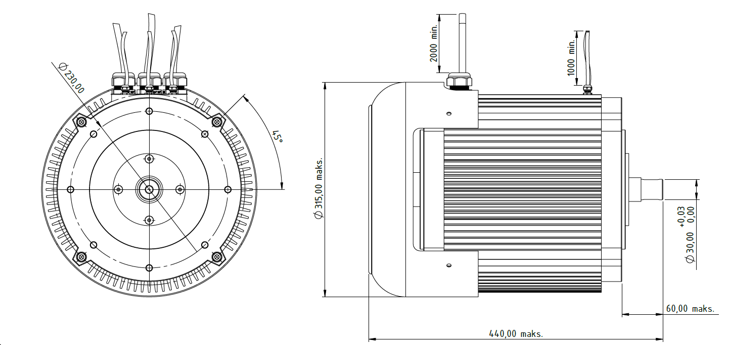
Basic Motor Parameters
Rated Power | W | 25000
Rated Speed | rpm | 6000
Rated Torque | Nm | 40
Rated Current | A | 180
Rated Voltage | V | 150
No-Load Speed | rpm | 7000
Max. Efficiency | % | 95
Electrical Parameters
Number of Phases |  | 3
Number of Poles |  | 16
Torque Constant (KT) | Nm/A | 0.215
Back EMF Constant (KE) | Vs/rad | 0.22
Terminal Resistance Phase to Phase (±%10) | mΩ | 2.75
Terminal Inductance Phase to Phase (±%30) | mH | Ld: 0,0234 / Lq: 0,0281
Thermal Data
Ambient Temperature | °C | -40...+85
Max. Winding Temperature | °C | +155
Physical Parameters
Outer Diameter | mm | 315
Shaft Diameter | mm | 30
Max. Lenght | mm | 440
Weight | gr | ~75000
Motor Connection
U | Phase A
V | Phase B
W | Phase C
Sensor Connection
U | Hall Sensor A
V | Hall Sensor B
W | Hall Sensor C
Connector Articles
Power | N/A
Signal | N/A

